📘 Zen Class Program – Case Study Documentation
✅ Step 1: Opening MongoDB Compass
Description:
MongoDB Compass is a GUI tool that allows you to interact with MongoDB databases visually.
Steps:
- Open the MongoDB Compass application from your system.
- Click Connect to connect to your local MongoDB server.

📸 Screenshot

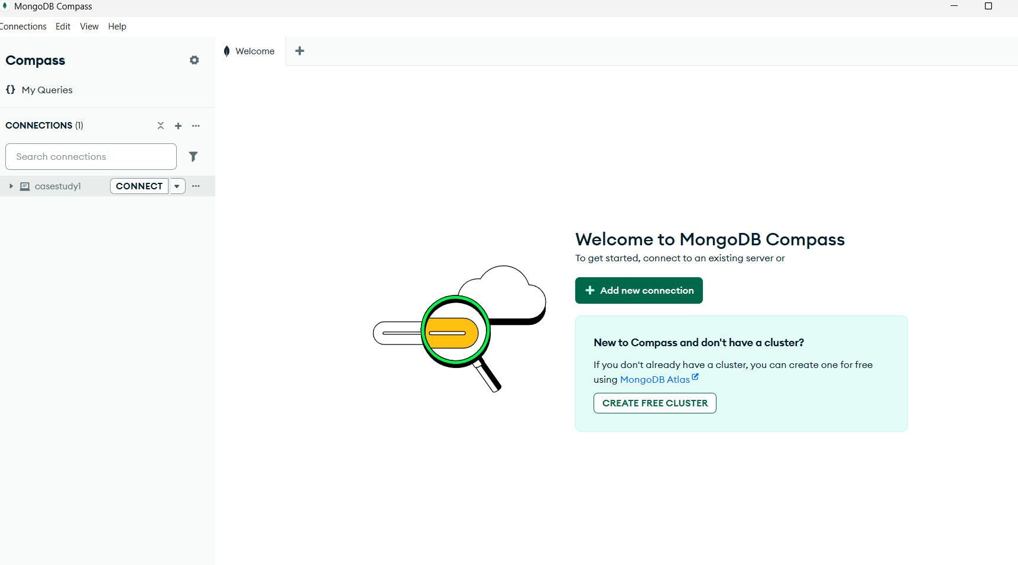

✅ Step 2: Create Database and First Collection (users)
Steps:
- Click on "Create Database".
- Enter:
  - Database Name: zenclass
  - Collection Name: users
- Click Create Database.
📸 Screenshot 1
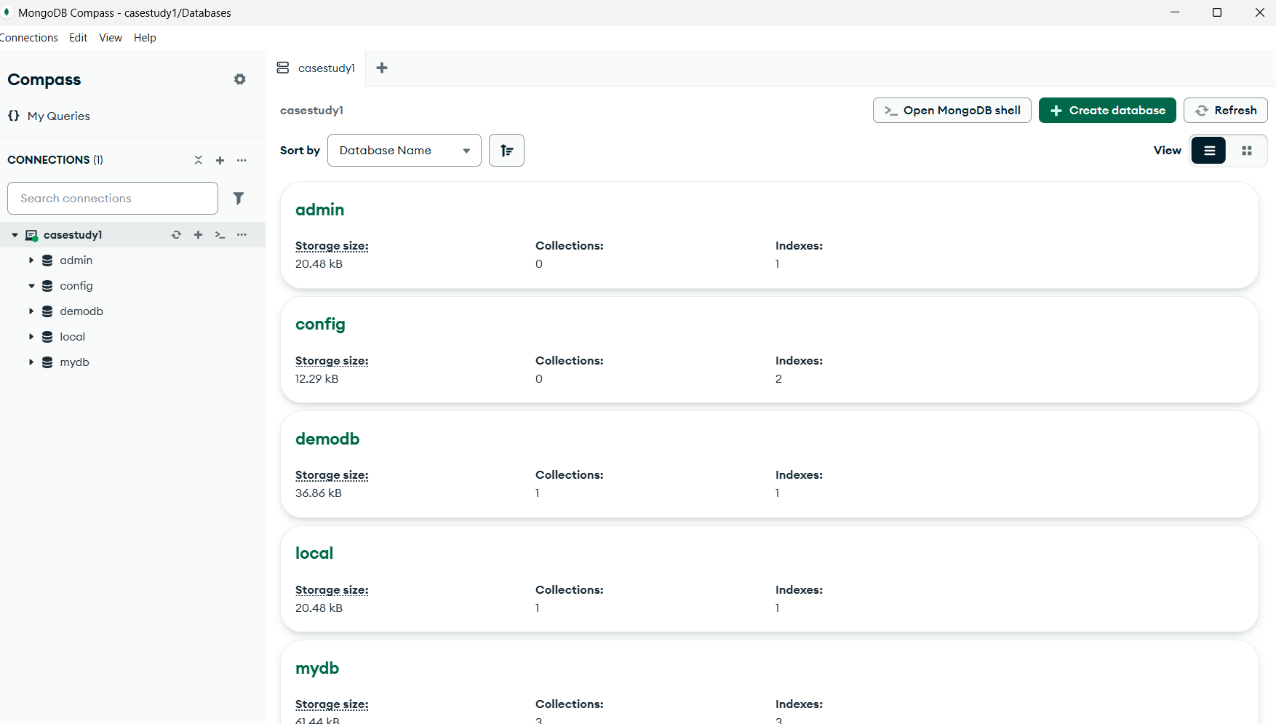
📸 Screenshot 2
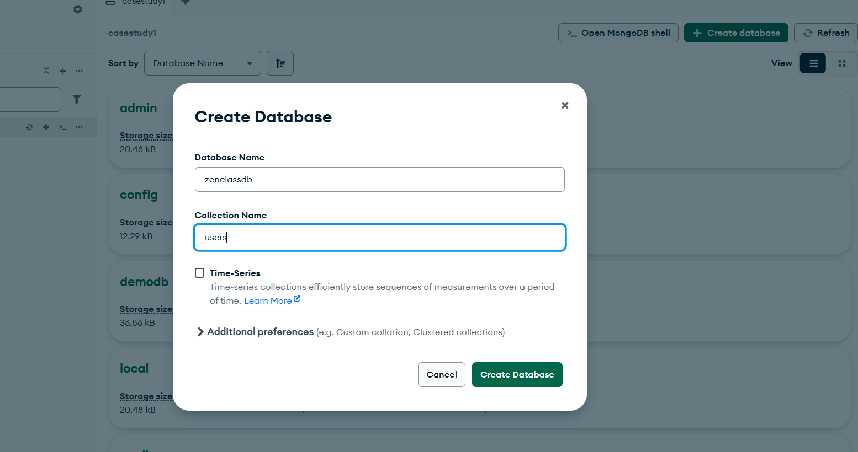

✅ Step 3: Collections Creation, Import, and Verification
This step covers creating 8 collections, importing JSON files, and verifying documents using MongoDB Shell & Compass.

🔹 3.1: Collection – users
3.1.1: Create users Collection
- Click the users collection under zenclass.
- Click Add Data > Import File.
- Choose the file users.json.
- File Type: JSON
- Click Import.
📸 Screenshot 1
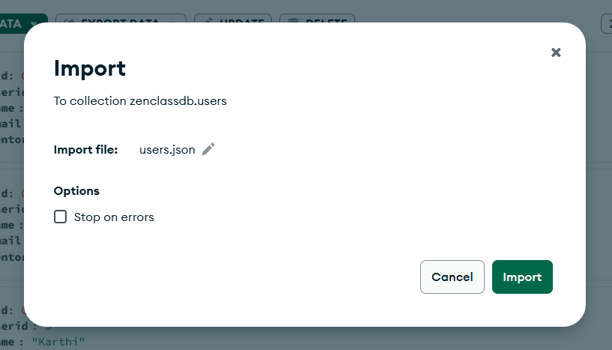
📸 Screenshot 2
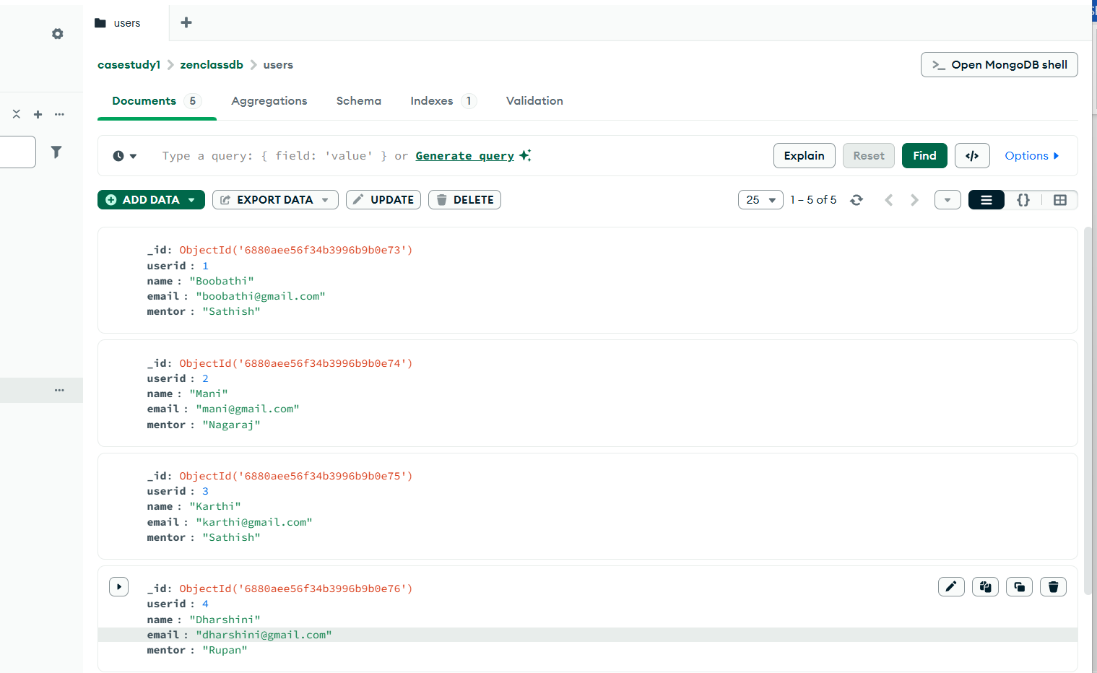
3.2.1: Verify Imported Data in Mongo Shell
Steps:
- Open Mongo Shell from Compass.
- Type the below command:
use zenclass
- Display documents:
db.users.find()
📸 Screenshot
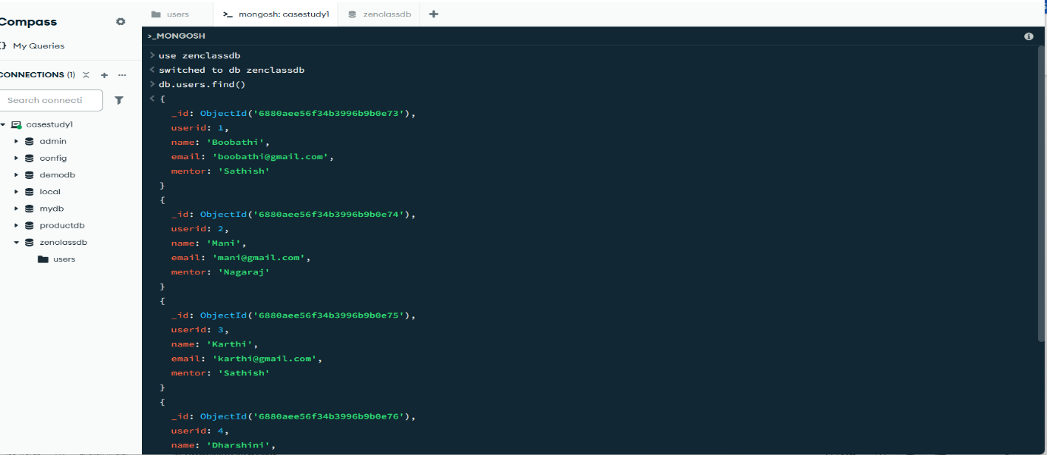

🔹 3.2: Collection – codekata
3.2.1: Create the codekata Collection
- In zenclass DB, click “Create Collection”
- Enter Name: codekata and click Create

📸 Screenshot
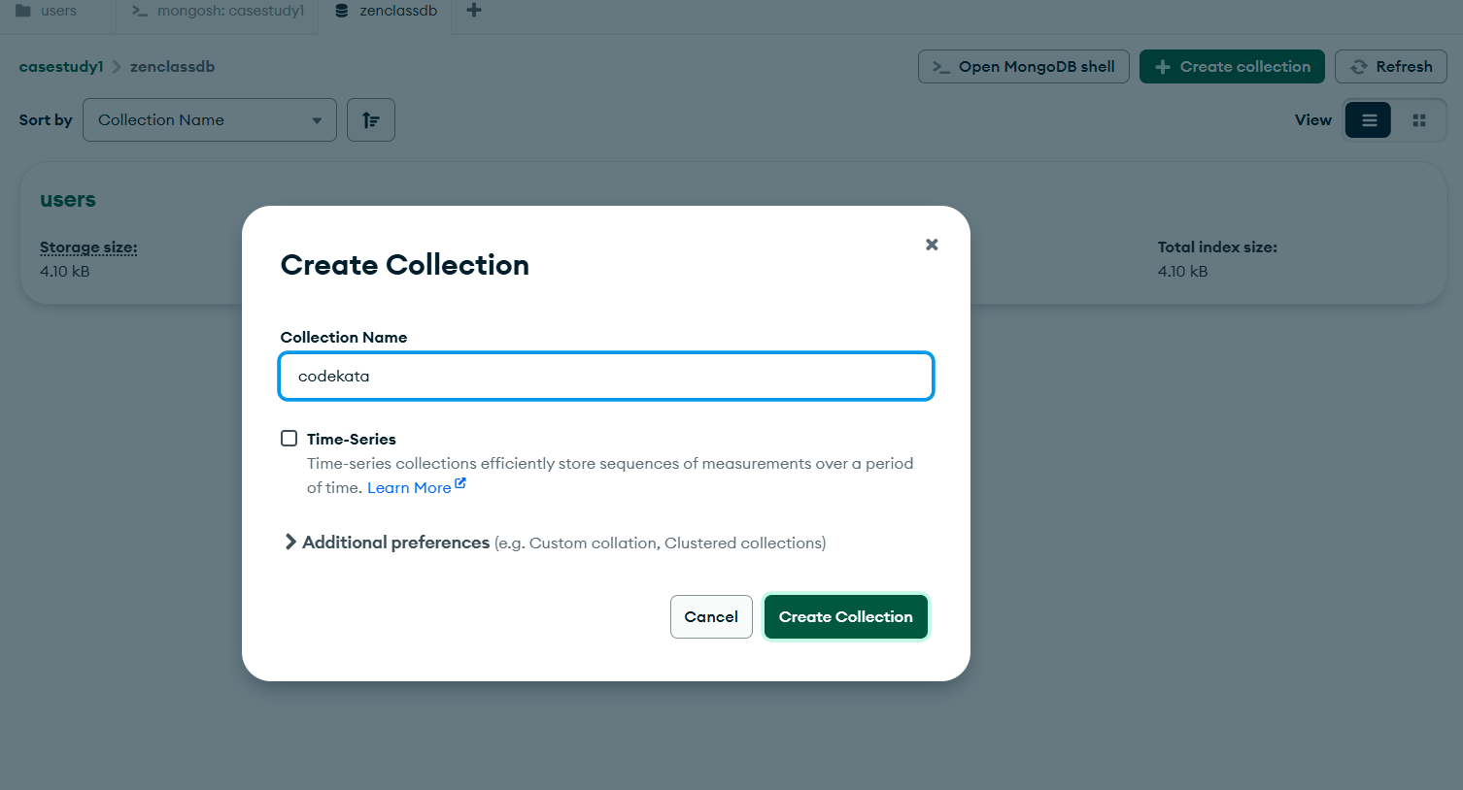
3.2.2: Import codekata.json
- Click codekata collection → Add Data > Import File
- Select codekata.json → File Type: JSON → Click Import
📸 Screenshot


3.2.3: Verify Data
Open mongoshell in compass and type:
db.codekata.find()
📸 Screenshot
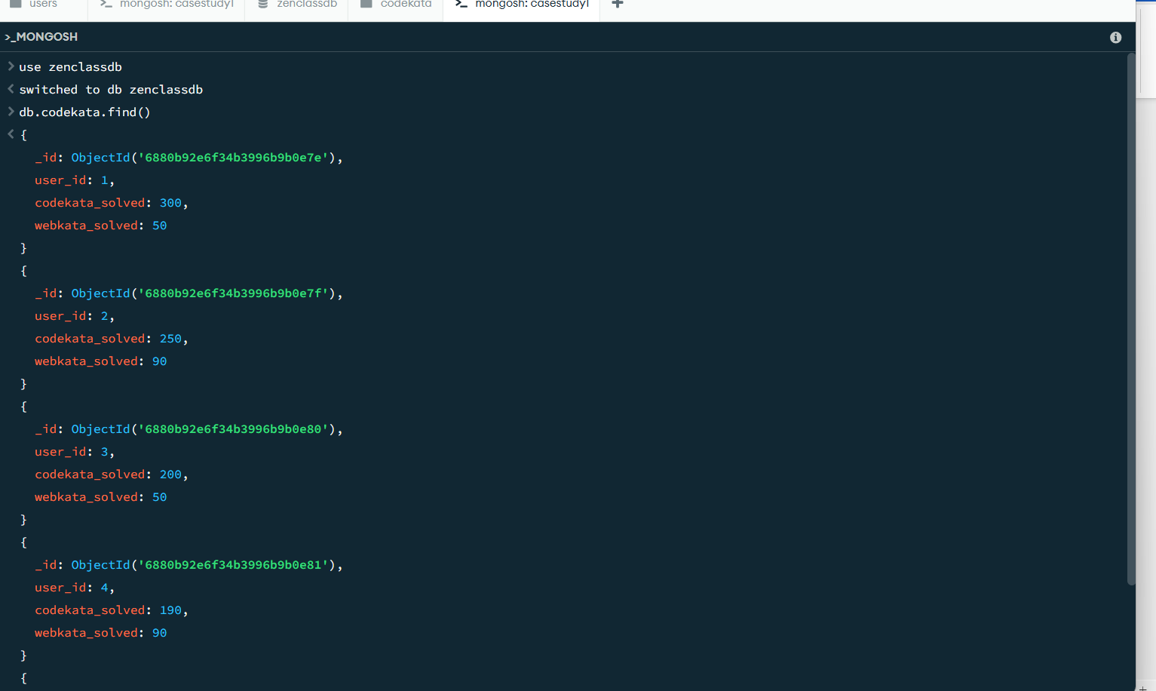

🔹 3.3: Collection – attendance
3.3.1: Create the attendance Collection
- Inside zenclass, click “Create Collection”
- Name it: attendance → Click Create

📸 Screenshot
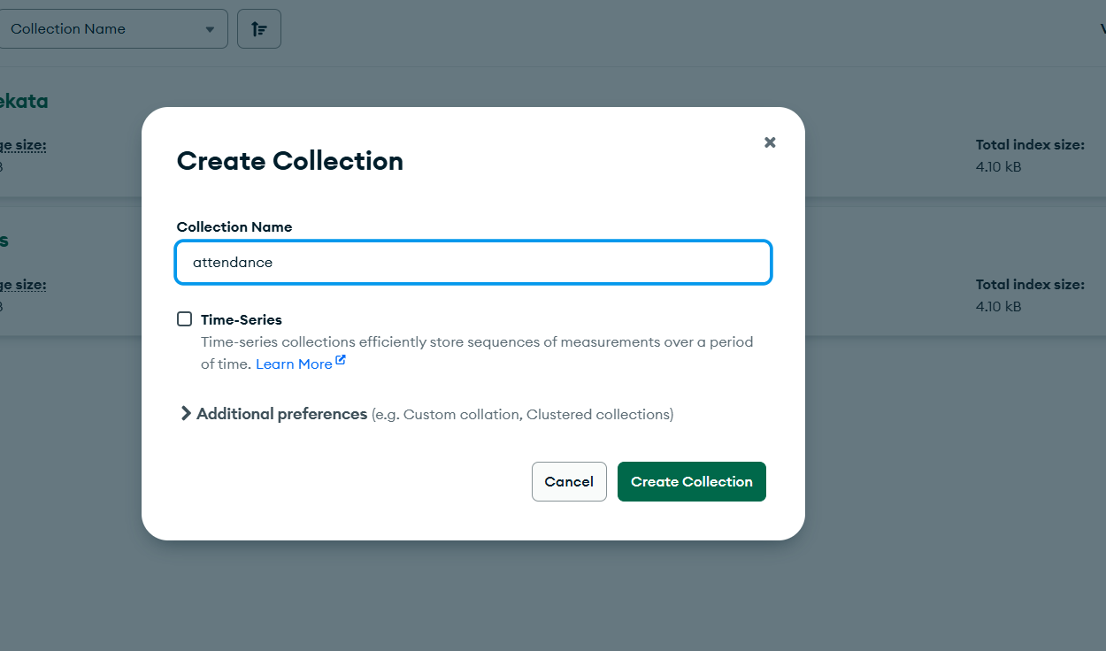
3.3.2: Import attendance.json
- Open the collection → Click Add Data > Import File
- Select attendance.json and Import.
📸 Screenshot
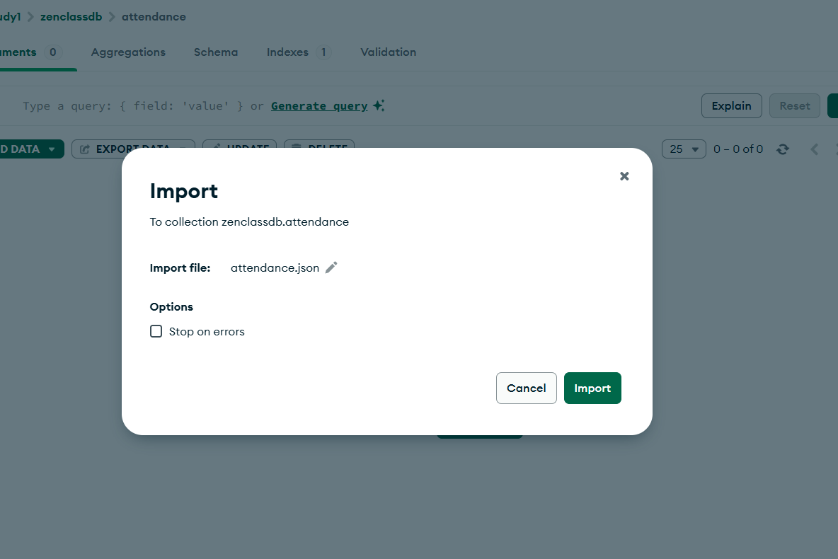
3.3.3: Verify Data
Click Open MongoDB shell in compass and type:
db.attendance.find()
📸 Screenshot
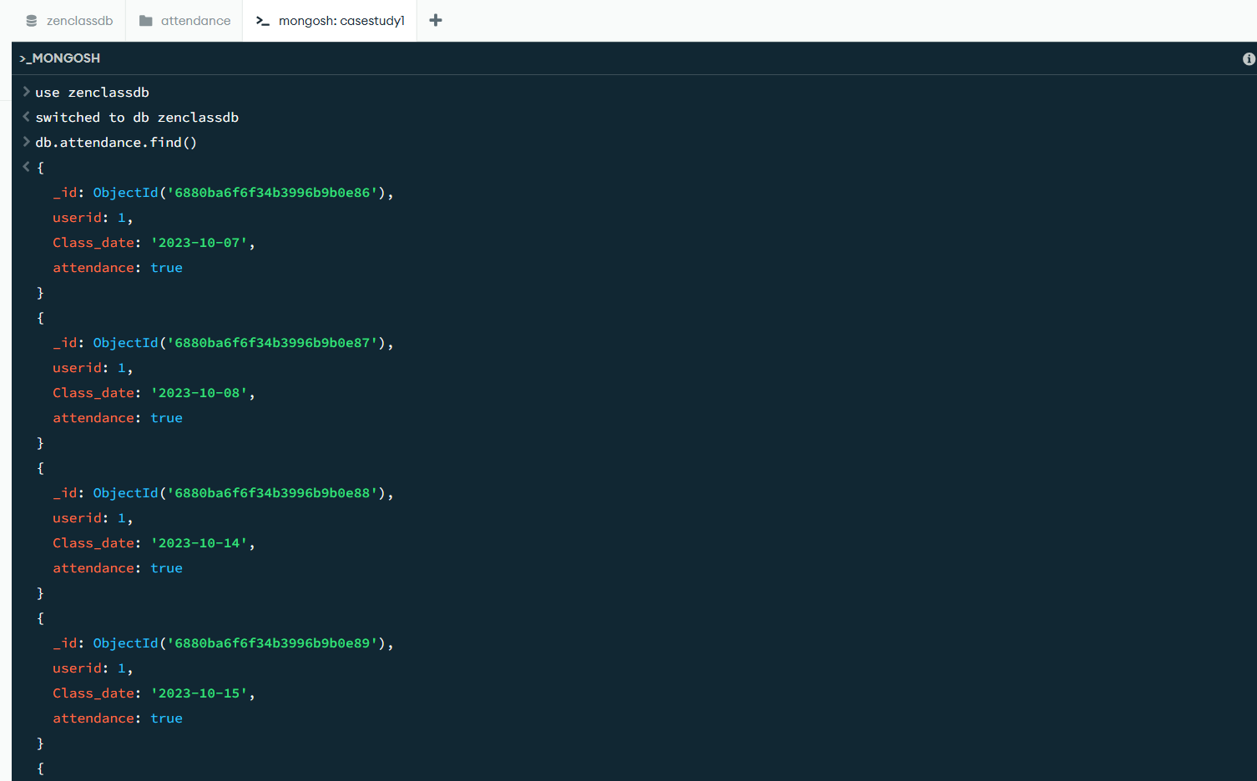

🔹 3.4: Collection – topics
3.4.1: Create the topics Collection
- Go to zenclass → Click Create Collection → Name: topics
📸 Screenshot
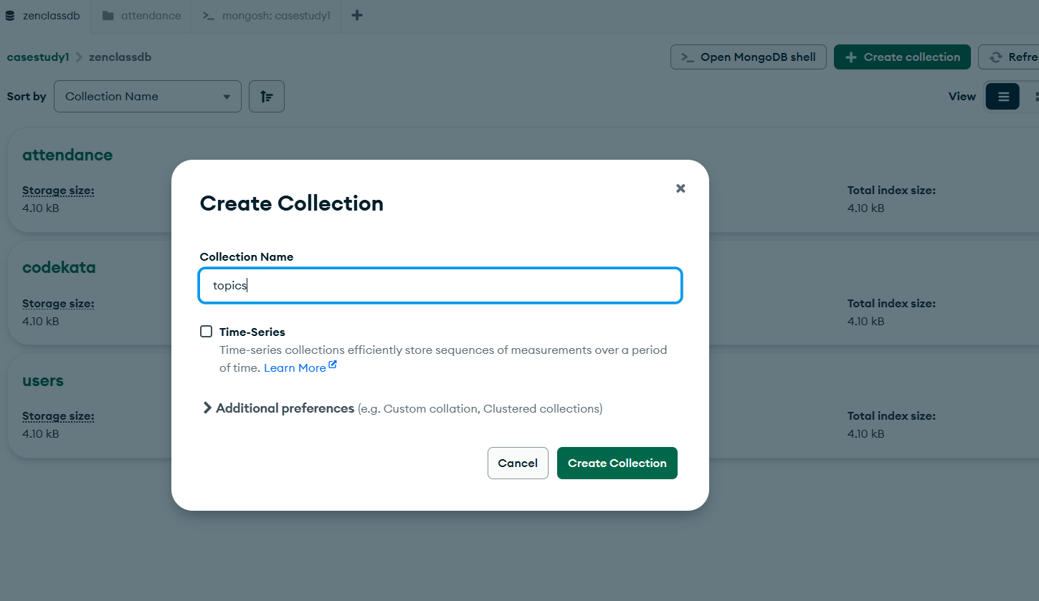
3.4.2: Import topics.json
- Open topics → Click Add Data > Import File
- Upload topics.json and import.
📸 Screenshot

3.4.3: Verify Topics Data
Click Open MongoDB shell in compass and type:
db.topics.find()

📸 Screenshot
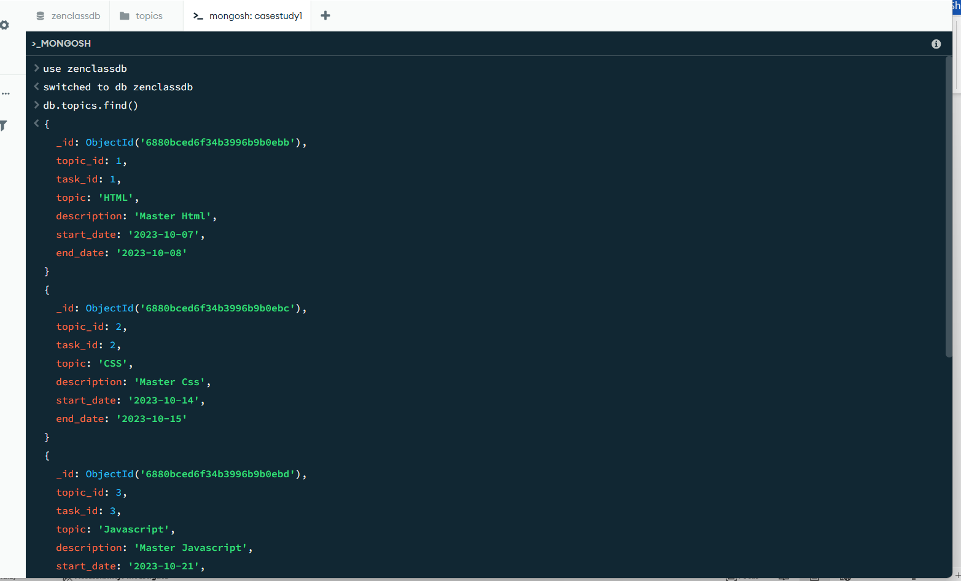

🔹 3.5: Collection – tasks
3.5.1: Create the tasks Collection
- In zenclass, click Create Collection → Name it: tasks
📸 Screenshot
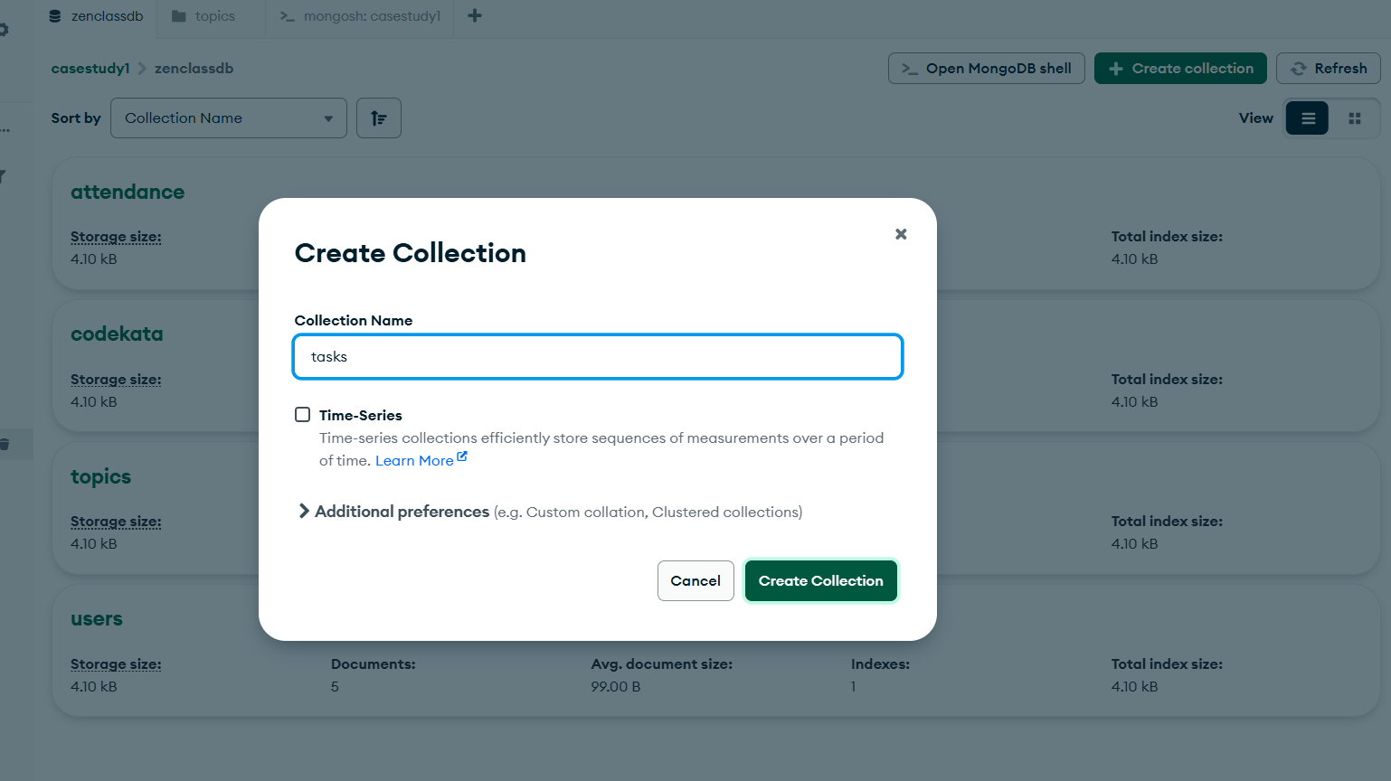
3.5.2: Import tasks.json
- Open the tasks collection → Click Add Data
- Choose tasks.json file and Import.
📸 Screenshot
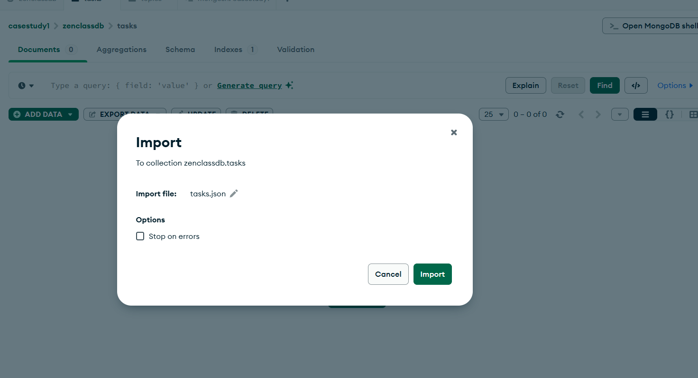
3.5.3: Verify Task Data
Click Open MongoDB shell in compass and type:
db.tasks.find()
📸 Screenshot
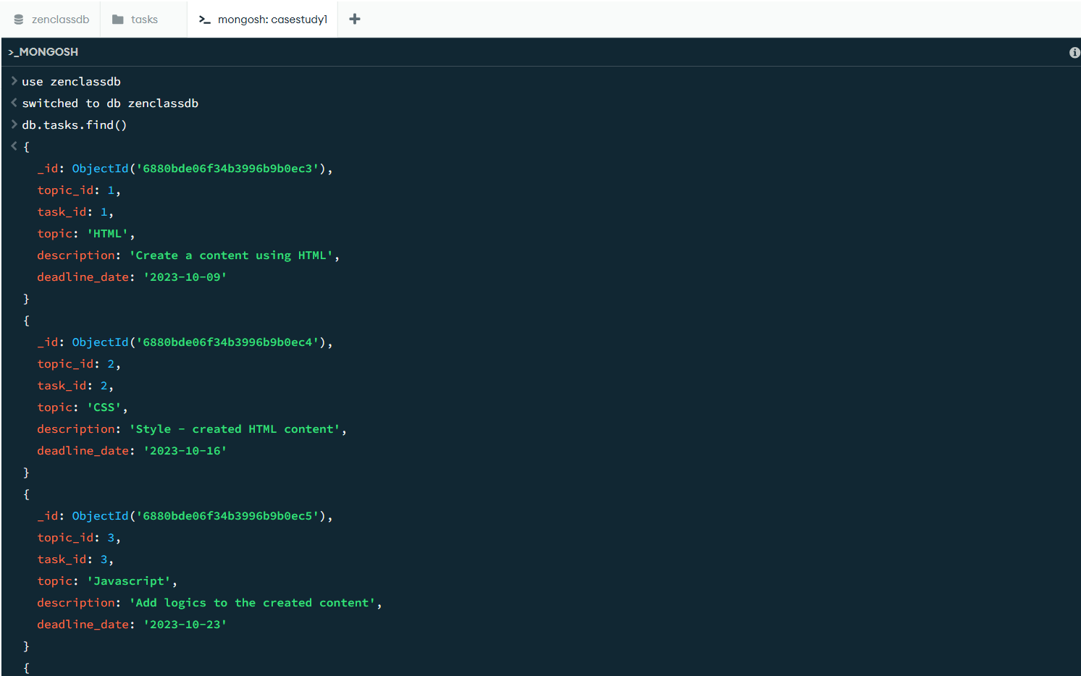

🔹 3.6: Collection – task_completion
3.6.1: Create the task_completion Collection
- Create new collection named task_completion under zenclass.
📸 Screenshot
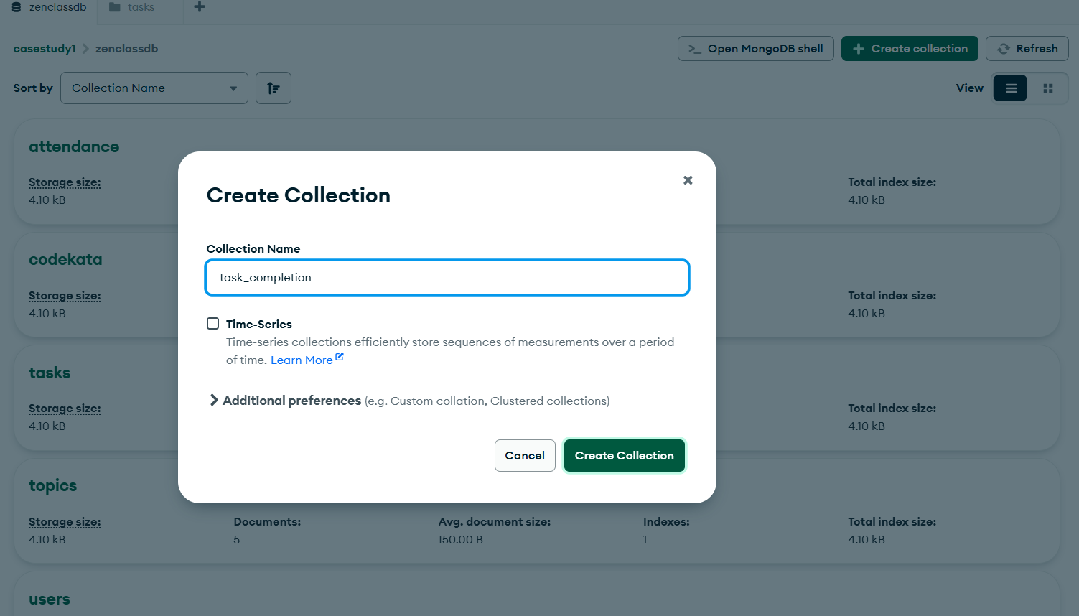
3.6.2: Import task_completion.json
- Open collection → Click Add Data > Import File
- Upload task_completion.json
📸 Screenshot
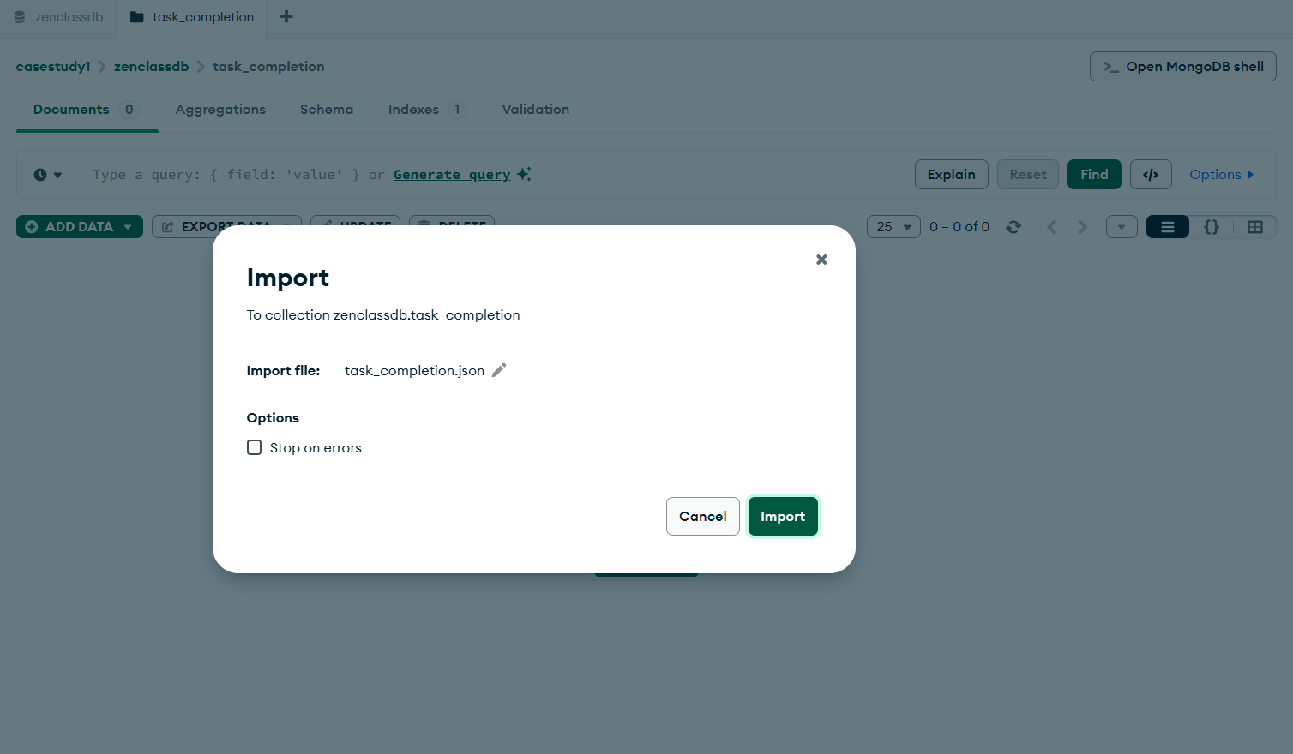
3.6.3: Verify Task Completion Data
Click Open MongoDB shell in compass and type:
db.task_completion.find()
📸 Screenshot
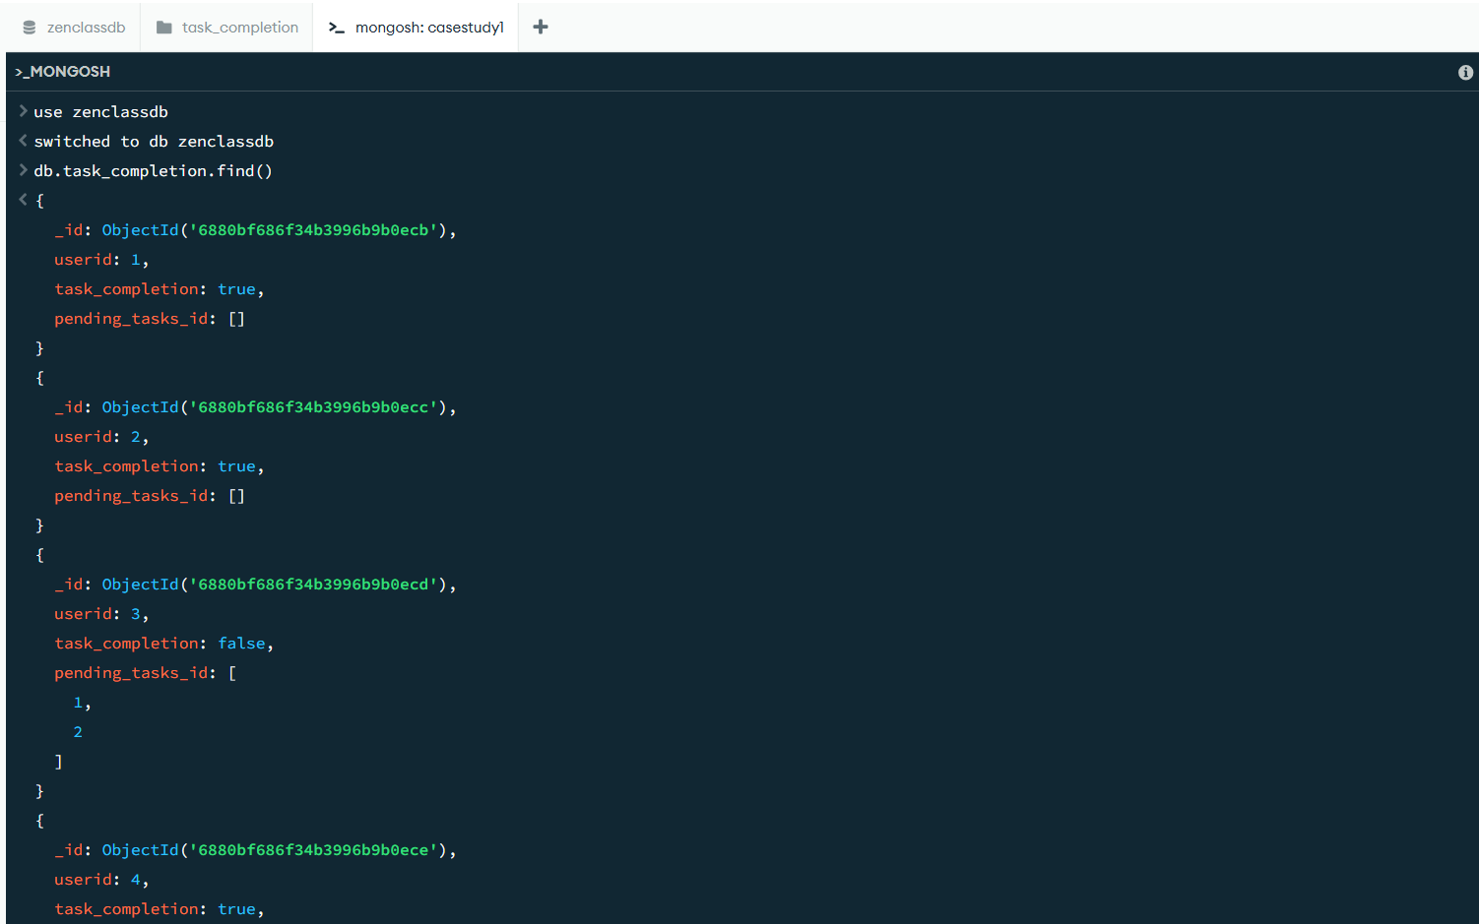

🔹 3.7: Collection – companydrives
3.7.1: Create companydrives Collection
- Create collection named companydrives under zenclass.

📸 Screenshot
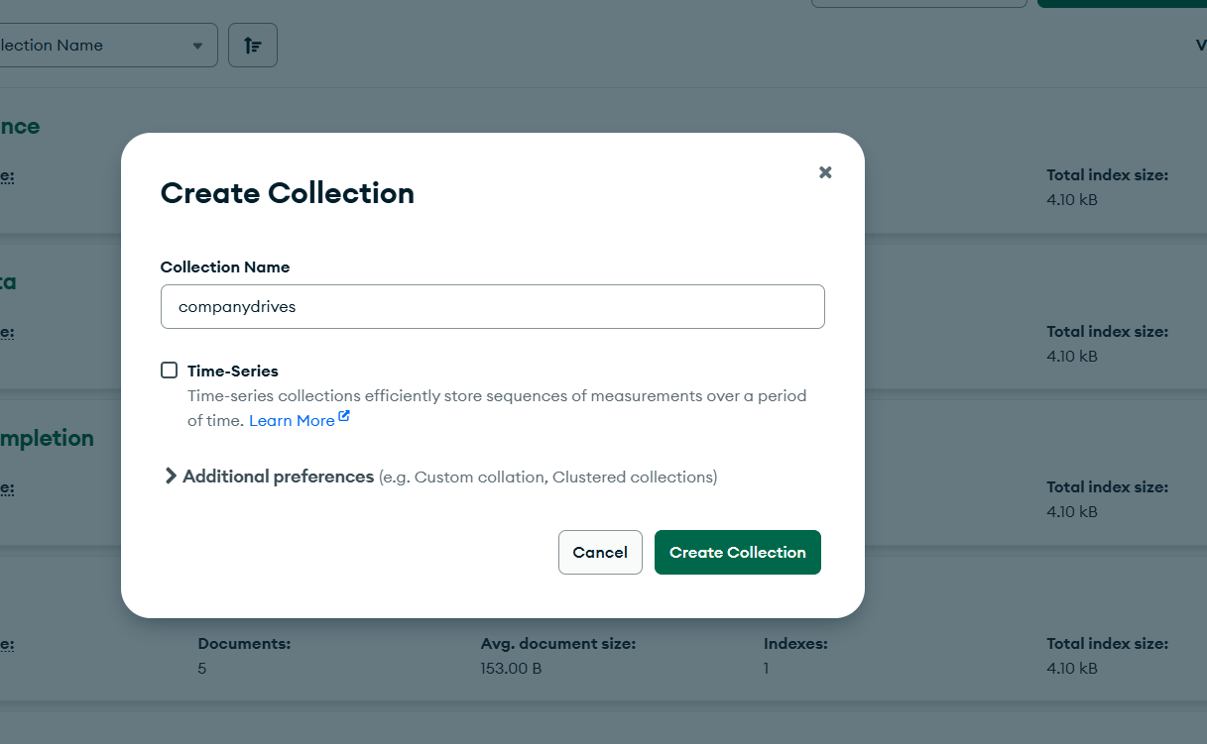

3.7.2: Import companydrives.json
- Click on collection → Import File → Select companydrives.json
📸 Screenshot
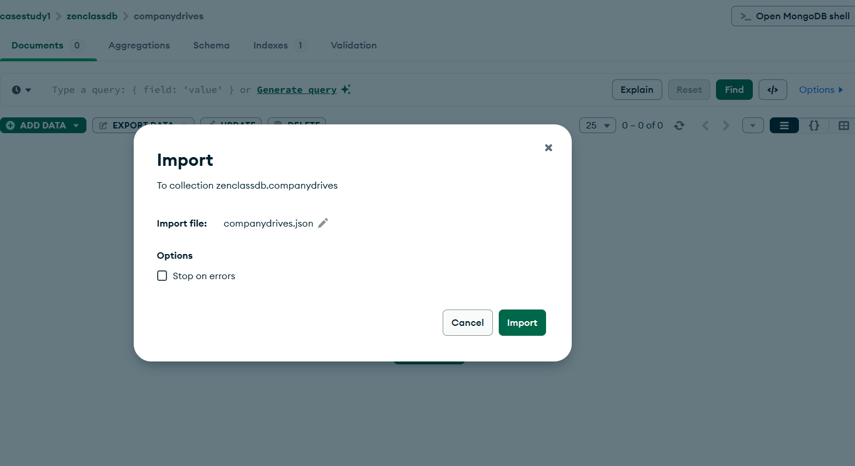
3.7.3: Verify Company Drives
Click Open MongoDB shell in compass and type:
db.companydrives.find()
📸 Screenshot
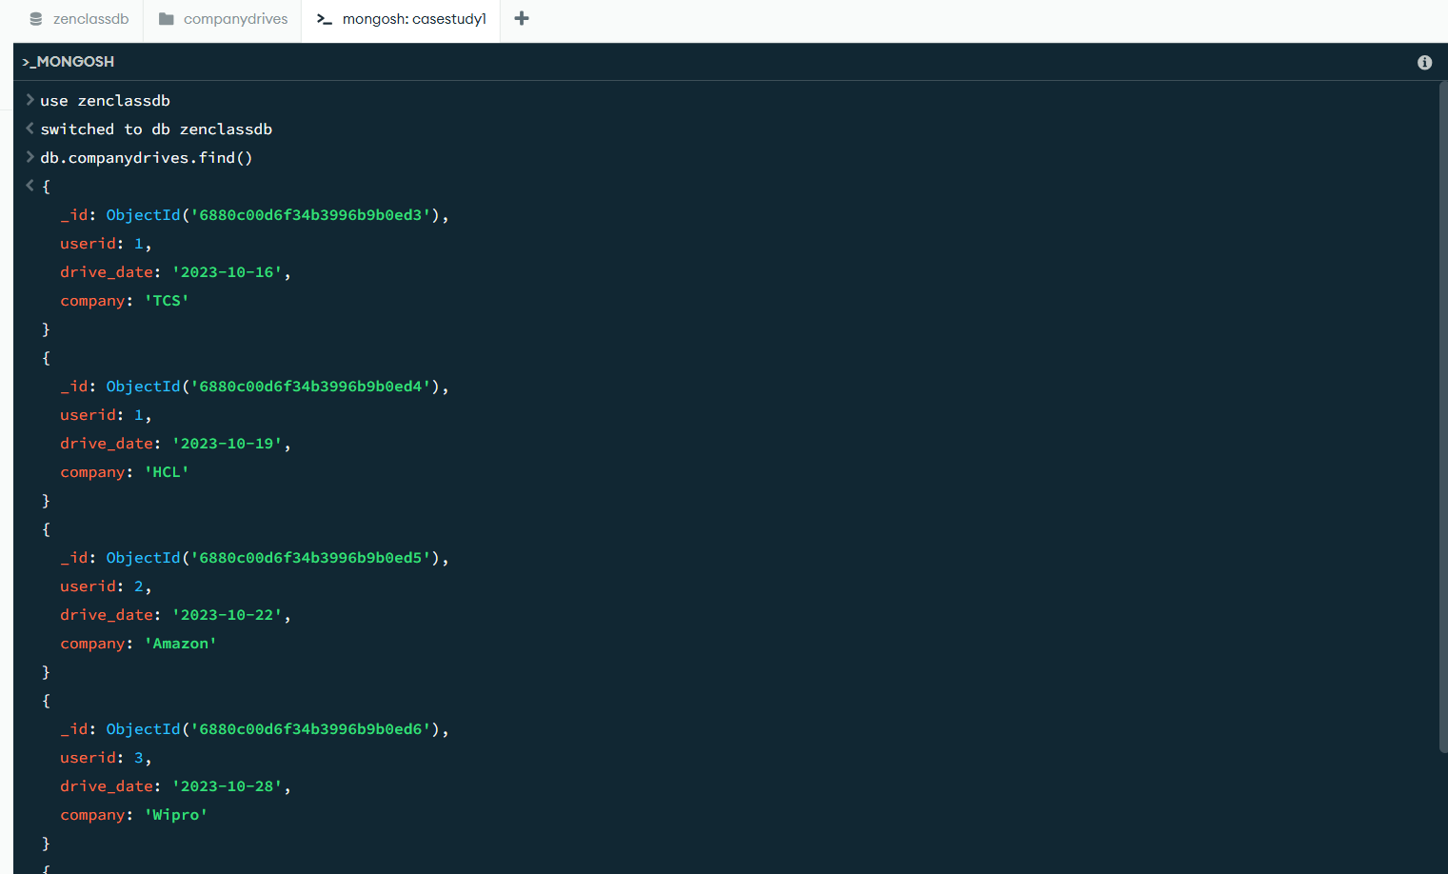

🔹 3.8: Collection – mentors
3.8.1: Create mentors Collection
- Final collection → Create mentors
📸 Screenshot
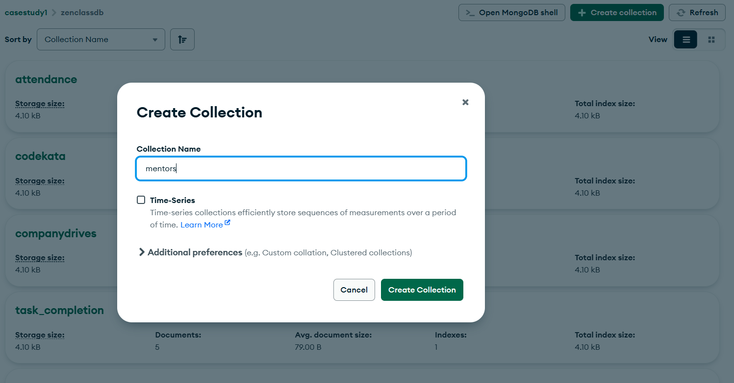
3.8.2: Import mentors.json
- Click on collection → Add Data → Import File → Select mentors.json
📸 Screenshot
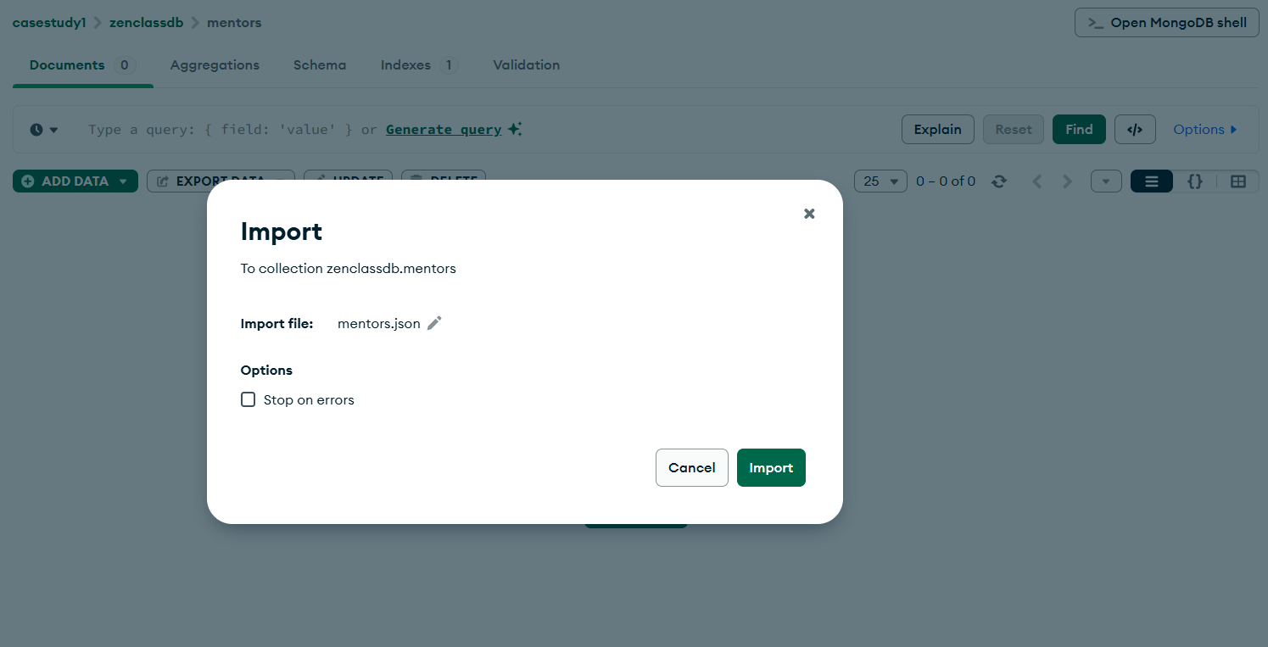
3.8.3: Verify Mentor Records
Click Open MongoDB shell in compass and type:
db.mentors.find()
📸 Screenshot
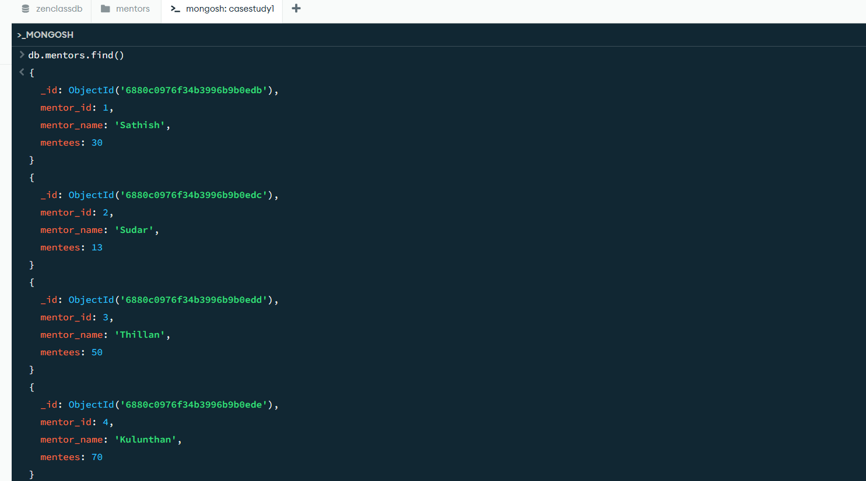

✅ Step 4: Verification of All Collections
After importing all collections, confirm their presence by running:
use zenclass
show collections
📸 Screenshot
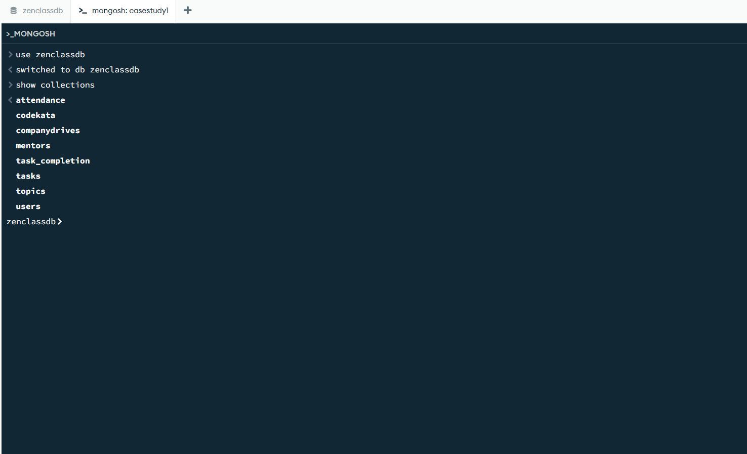

✅ Step 5: Execute the Queries
1. Find all the topics and tasks which were taught in October 2023
🔍 Query for topics:
db.topics.find({
start_date: {
$gte: ISODate("2023-10-01"),
$lte: ISODate("2023-10-31") }})

🔍 Query for tasks:
db.tasks.find({
deadline_date: {
$gte: ISODate("2023-10-01"),
$lte: ISODate("2023-10-31") }})

📝 Explanation:
These queries check start_date for topics and deadline_date for tasks that fall within October 2023.
📸 Screenshot

✅ 2. Find all the company drives between 15-Oct-2023 and 31-Oct-2023
db.companydrives.find({
drive_date: {
$gte: ISODate("2023-10-15"),
$lte: ISODate("2023-10-31")
}
})
📝 Explanation:
Matches companies like TCS, HCL, Amazon that conducted drives in the specified range.
📸 Screenshot

✅ 3. Find the total problems solved by each user in codekata
db.codekata.aggregate([
{
$project: {
user_id: 1,
total_problems_solved: {
$add: ["$codekata_solved", "$webkata_solved"]
}
}
}
])
📝 Explanation:
Adds codekata_solved + webkata_solved for each user and shows the total.
📸 Screenshot

✅ 4. Find all mentors who have more than 15 mentees
db.mentors.find({
mentees: { $gt: 15 }
})
📝 Explanation:
Filters mentors like Sathish, Parthiban, Vijay, etc. with large batches.
📸 Screenshot

✅ 5. Find number of users who were absent and didn’t submit tasks between 15-Oct and 31-Oct-2023
🔍 Step 1: Get list of absent users
const absentUsers = db.attendance.distinct("userid", {
Class_date: {
$gte: ISODate("2023-10-15"),
$lte: ISODate("2023-10-31")
},
attendance: false
})
🔍 Step 2: Find how many of them also did not submit tasks
db.task_completion.find({
userid: { $in: absentUsers },
task_completion: false
}).count()
📝 Explanation:
Step 1 filters users who were absent on any day from 15–31 Oct.
Step 2 counts those users who also have not completed tasks.
📸 Screenshot

📌 Conclusion:
In this case study, I:
- Explored MongoDB Compass GUI.
- Created a database and imported 8 collections using .json files.
- Verified documents using Mongo Shell.
- Wrote and executed 5 real-world queries involving date filtering, aggregation, joins (via logic), and condition checks.
- Learned hands-on MongoDB operations for real-world datasets.

